Exercise1

* Input a text in the console.
* Count the number of times the "abc" pattern appears in a string.

1. What will be the **result** for these outputs?

|  |  |
| --- | --- |
| **Input** | **Output** |
| abbcdef | 0 |
| abcfabc | 2 |
| adabcfbc | 1 |

1. Choose the more relevant blocks and draw your structure flowchart.

Input()

Sum=0

Len(text)

Text[i]==a b c

Sum+=1

print

1. 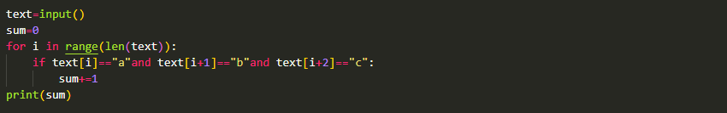Adapt code from a previous session to solve this problem.

* Input a text in the console, only number.
* Multiple all the number before the first apparition of 6 and 1 if 6 is in the first position.

Exercise2

1. What will be the **result** for these outputs?

|  |  |
| --- | --- |
| **Input** | **Output** |
| 123456789 | 120 |
| 5263 | 10 |
| 71256 | 70 |
| 45 | 20 |
| 625 | 1 |

1. Draw your structure flowchart.

word=Input()

I=0

Mult=0

I<Len(word) and int(word[i]) !=6

Mult*=int(word[i])

I+=1

print

1. Use the following code and adapt it so as not to use the repetitive (for) loop.

word = input()

i = 0

mult = 1

while i < len(word) and int(word[i]) != 6:

mult *= int(word[i])

i += 1

print(mult)

word = input()

i = 0

mult = 1

for i in range(len(word)):

if i < len(word) and int(word[i]) != 6:

mult *= int(word[i])

i += 1

print(mult)

Exercise3

* Input a number.
* Display numbers from 1to that number

|  |  |
| --- | --- |
| **Input** | **Output** |
| 4 | 1 2 3 4 |
| 2 | 1 2 |
| 5 | 1 2 3 4 5 |
| 3 | 1 2 3 |
| 0 |  |

1. Create a flowchart to solve this problem. Which loop block will you choose and why?

Start សម្រាប់ ចាប់ផ្ដើម

action

Input សម្រាប់ បញ្ចូលលេខ

Input

While សម្រាប់ loop នៃចំនួន text ដែលយើងបញ្ចូលទៅ

While

Input សម្រាប់ Store នូវចំនួនលេខដែលវា loop

action

Output សម្រាប់ Print Result

Output

1. Review the code and find **the error** and explain them.

number = int(input())

result = ""

for index in range(number):

result = result + " " + str(index + 1)

print(result)

1. Write your own good code to solve this problem. This time, you can’t use the **for condition**.

text = int(input())

i = 0

number = 0

while i < text:

number = number + 1

i = i + 1

print(number, end=" ")